Assignment #3 (Total 100)
Formatting:
If you're coding in a Jupyter Notebook, just submit your ipynb file with all the outputs. If you're using a py file, include all the outputs in a pdf along with your Python code.

- On “Yelp” search for restaurants in “Boston, MA 02108”.
- Get the URL for the first three pages of results and utilize Beautiful Soup to get all of reviews from these pages.
- Use afinn method for sentiment analysis. The output should be a data frame with each review, the afn.score and label you create based on the score (0: neutral, <0 negative and >0 positive). This is an example of the afinn sentiment analysis output.
- Add the name of the restaurant to the data frame in question 3.
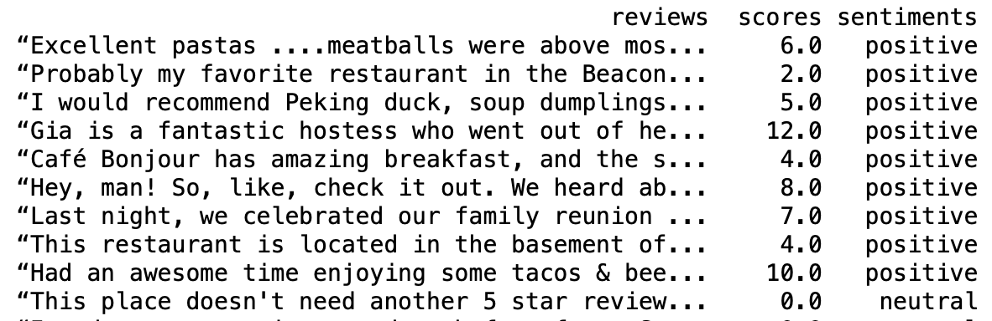

- Use NRCLex method for sentiment analysis. Pass each review to NRCLex and get top_emotions for that review, store all reviews and their top emotions in a text file. Here is an example of how it should look like for each review:
“Food: 11/10, WOW.

Everything was AMAZING, quality of fish and avocados were incredible, everything tasted super fresh! Our favorite definitely had to be the…” more : [('trust', 0.3333333333333333), ('positive', 0.3333333333333333), ('joy', 0.3333333333333333)]

Grading Criteria:
Total: 100
- 0
- 0
- 40
- 10
- 50

